COST Action CA23113 CliMent
COMMUNICATION ACTIVITY
- Website News (125 words)
Nursing students are on the frontline of climate-related health challenges. As part of COST Action CA23113 (CliMent) WG1, we implemented the Spain node of a cross-cultural survey on eco-anxiety and mental health at the University of Barcelona (September 2025). The survey package yielded ≥275 completed responses and mirrors a parallel effort in Türkiye. Standardised procedures and bilingual instruments were used to enable cross-country psychometric validation and modelling of country/individual predictors. Next steps (Oct–Dec 2025) include data collection in İstanbul/Türkiye, data merging, reliability/invariance testing, and pooled analyses. This work was hosted by the University of Barcelona, Faculty of Nursing and led by Merve Murat Mehmed Ali (Lecturer, PhD, RN; University of Health Sciences, İstanbul) with mentors Prof. A.R. Moreno Poyato and Prof. S. Sánchez Balcells.
Acknowledgement line:
Funded by a COST STSM grant under Action CA23113.
- Social Media Posts
  - LinkedIn:
Proud to complete the Spain node of our CliMent WG1 survey on eco-anxiety and mental health among nursing students (University of Barcelona; September 2025). ≥275 responses using harmonised, bilingual instruments—designed for cross-country validation and modelling predictors. Next steps: merge datasets (Spain+Türkiye), run reliability/invariance analyses, and draft the Q1 manuscript.
Thanks to mentors Prof. A.R. Moreno Poyato and Prof. S. Sánchez Balcells.
@CliMent COST, @Antonio R. Moreno Poyato; @Sara Sanchez Balcells; @Merve MURAT MEHMED ALİ
#CliMent #COSTAction #ClimateChange #MentalHealth #EcoAnxiety #Research #Nursing

  - X/Twitter:
Finished the Spain node of our cross-cultural survey on eco-anxiety & mental health among nursing students (WG1–T1.2, official name: @COST Action CA23113). ≥275 completes, harmonised measures, ready for cross-country psychometrics. Thanks to COST Action and UB.
#CliMent #EcoAnxiety #Nursing #MentalHealth #WG1

  - Instagram:
Spain node done ≥275 nursing students surveyed on eco-anxiety & mental health (official name: @COST Action CA23113). Next: merge with Türkiye + analyses!
#EcoAnxiety #MentalHealth #Nursing #CliMent #COST
Social Media Visual
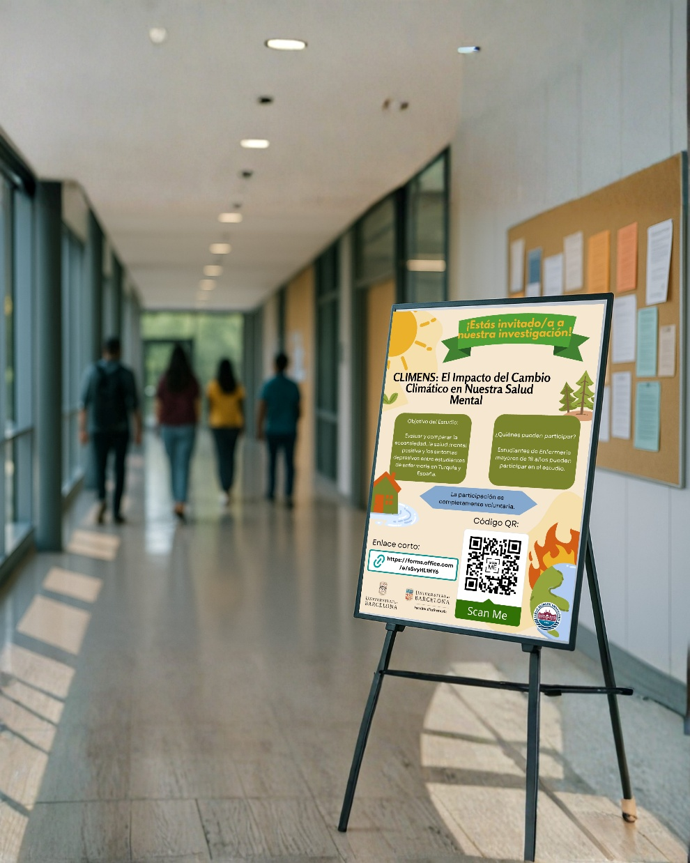
Sub-text: Research poster announcing a cross-cultural survey on eco-anxiety and mental health among nursing students at the University of Barcelona, aligned with CliMent WG1.
#CliMent #COSTAction #ClimateChange #MentalHealth #EcoAnxiety #Research #Nursing

