Report on the outcomes of a Virtual Mobility

Action number: CA23113
Grantee name: Jane Spiteri

Virtual Mobility Details
Title: Coping with unpleasant eco-emotions: A scoping review (An Open Science Framework Registration and Publication of a Scoping Review Protocol (WG2))
Start and end date: 13/10/2025 to 27/10/2025

Description of the work carried out during the VM
Description of the virtual collaboration and activities carried out during the VM, with focus on the work carried out by the grantee. Any deviations from the initial working plan shall also be described in this section. (500 words)
During the Virtual Mobility (13–27 October 2025), I collaborated closely with the Working Group (WG2) Leader, Dr. Marie-Laure Parmentier, to finalise and register the Scoping Review Protocol on Coping Strategies for Climate Change-Related Mental Health Impacts on the Open Science Framework (OSF). The VM built directly on the preparatory work outlined in the application, focusing on two major outputs: the OSF registration and the development of a journal-ready scoping review protocol manuscript.
The first phase of the VM involved the finalisation and registration of the OSF protocol. I drafted all the required sections in alignment with Joanna Briggs Institute (JBI) methodology and PRISMA-ScR guidelines, including the rationale, objectives, eligibility criteria, search strategy, data charting, and synthesis methods. Multiple online meetings were held with Dr. Parmentier to refine and align the protocol with the objectives of WG2 and the broader CliMent Action. Feedback was obtained from co-authors and WG2 members through collaborative online discussions and shared document reviews. Following their approval, the OSF protocol was successfully registered and made publicly available, ensuring transparency and reproducibility (Spiteri, J., Parmentier, M., Sampaio, F., Soares, A. J., Cadeddu, C., Gjoneska, B., … Innocenti, M. (2025, November 3). Coping with unpleasant eco-emotions: A scoping review. Retrieved from osf.io/gauhk). Kindly see the screenshot below:
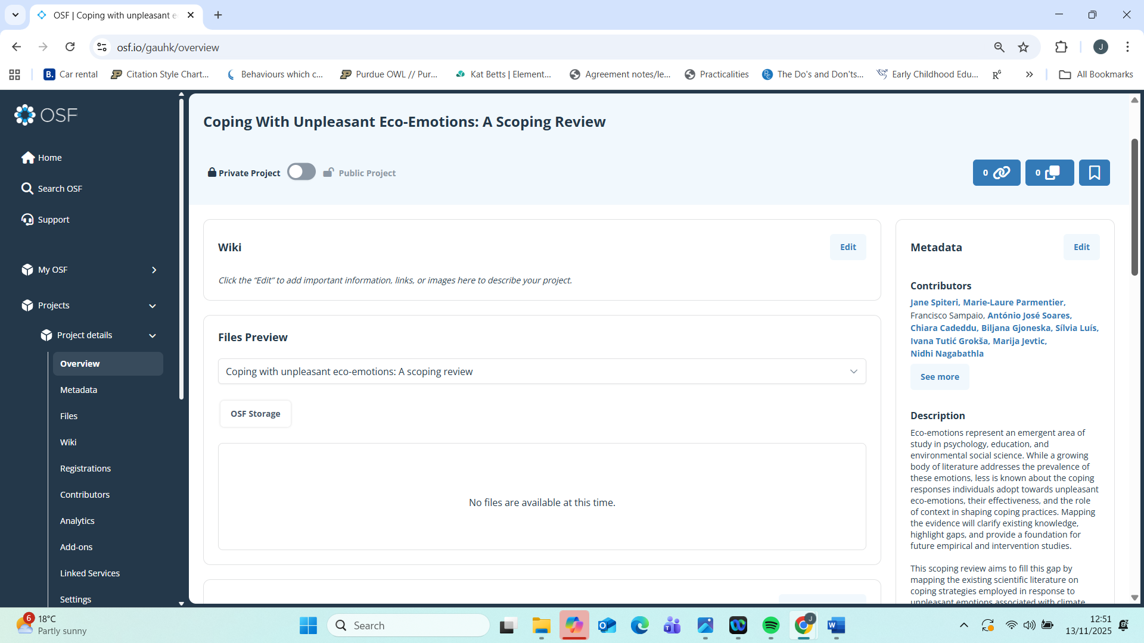

The second phase centred on developing and finalising the scoping review protocol manuscript for submission to a peer-reviewed journal. Drawing on the OSF content, I expanded and refined the methodological justifications and contextualised the study within the existing literature on climate change-related mental health and coping strategies. The draft was reviewed by Dr. Parmentier, WG2 members, and Prof. Francisco Sampaio (COST Action Chair), and WG2 members, whose feedback helped ensure methodological robustness and coherence with the Action’s objectives. Furthermore, a number of WG2 members, including Marie-Laure Parmentier and Matteo Innocenti, supported by contributors such as Octav Candel and Marlis Wullenkord (background check and refinement of the research question), and Antonio José Soares (definition of inclusion and exclusion criteria). They shared insights from preliminary searching, screening, and the categorisation of coping strategies. Their empirical input has strengthened the methodological accuracy of the OSF registration and ensure complementarity between the protocol and the ongoing review. The screenshot below shows a snapshot of the working document of the scoping review protocol.
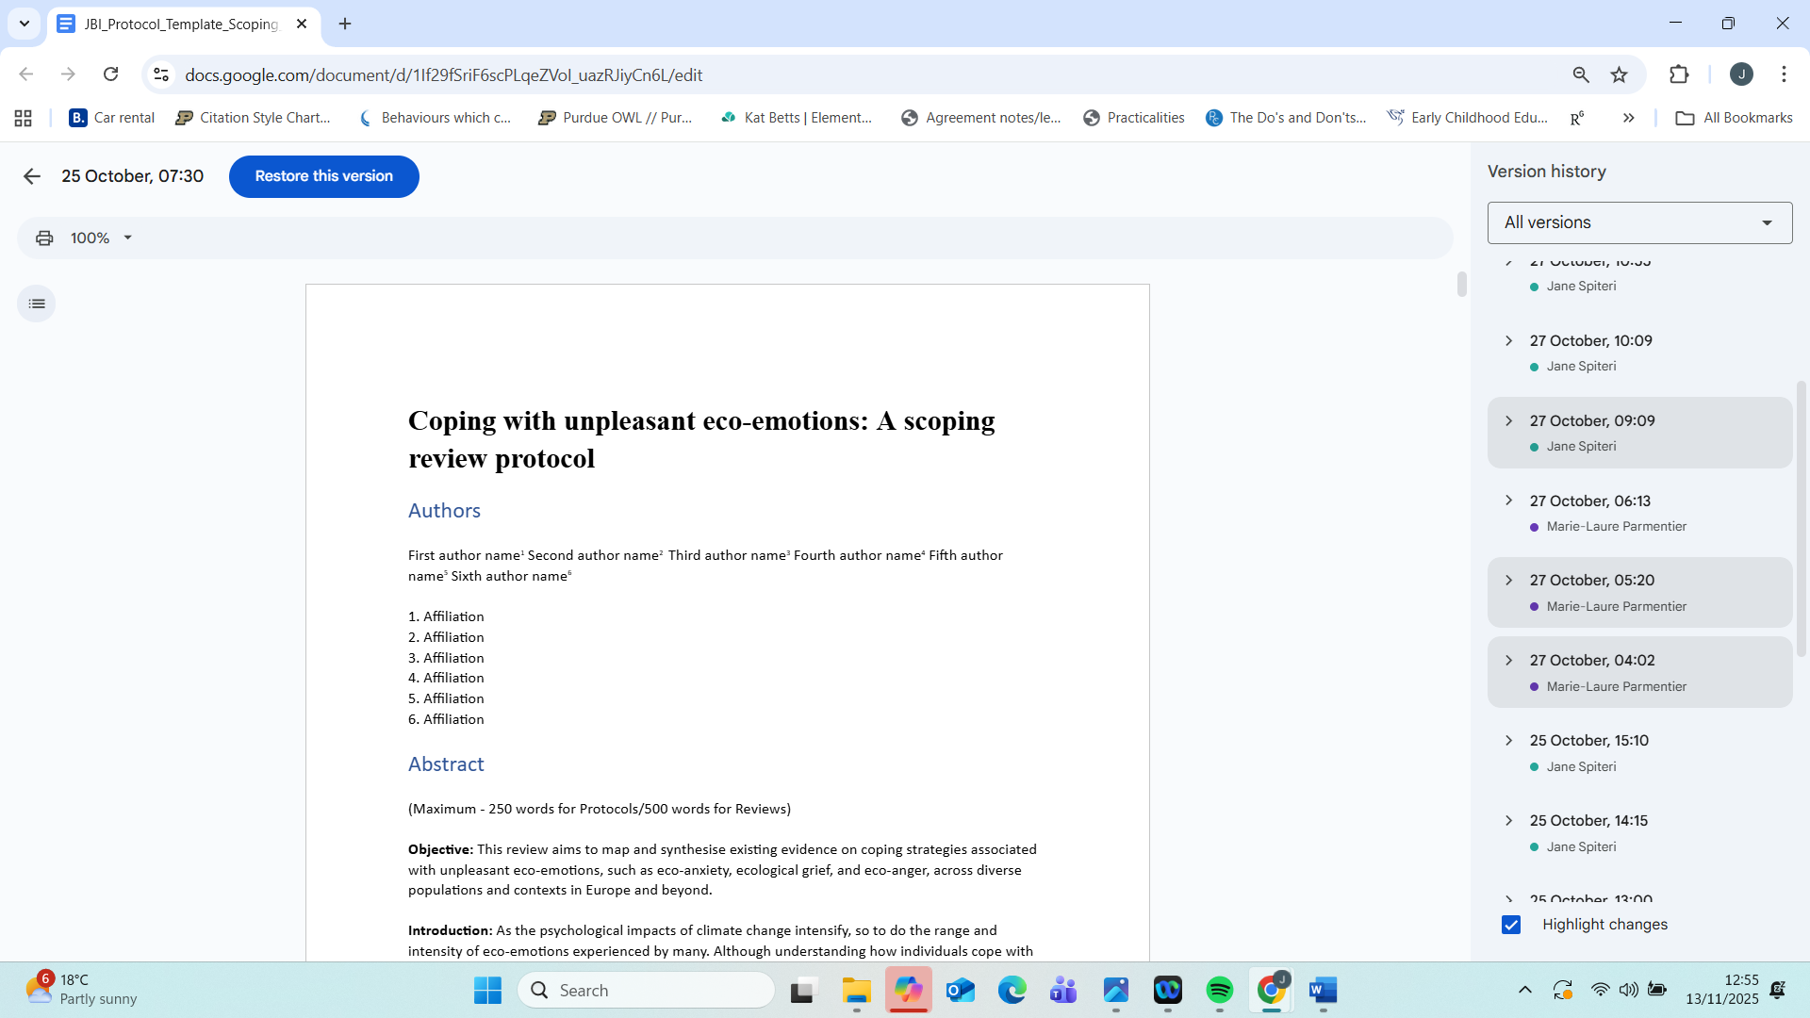

In addition, an online meeting was organised to brief WG2 members on the OSF registration and to discuss next steps for data extraction and synthesis. This meeting also served as a capacity-building exercise, introducing early career researchers and Inclusiveness Target Country (ITC) participants to systematic review methodology and open science practices. The screenshots below show instances from the powerpoint presentation used during the online meeting.
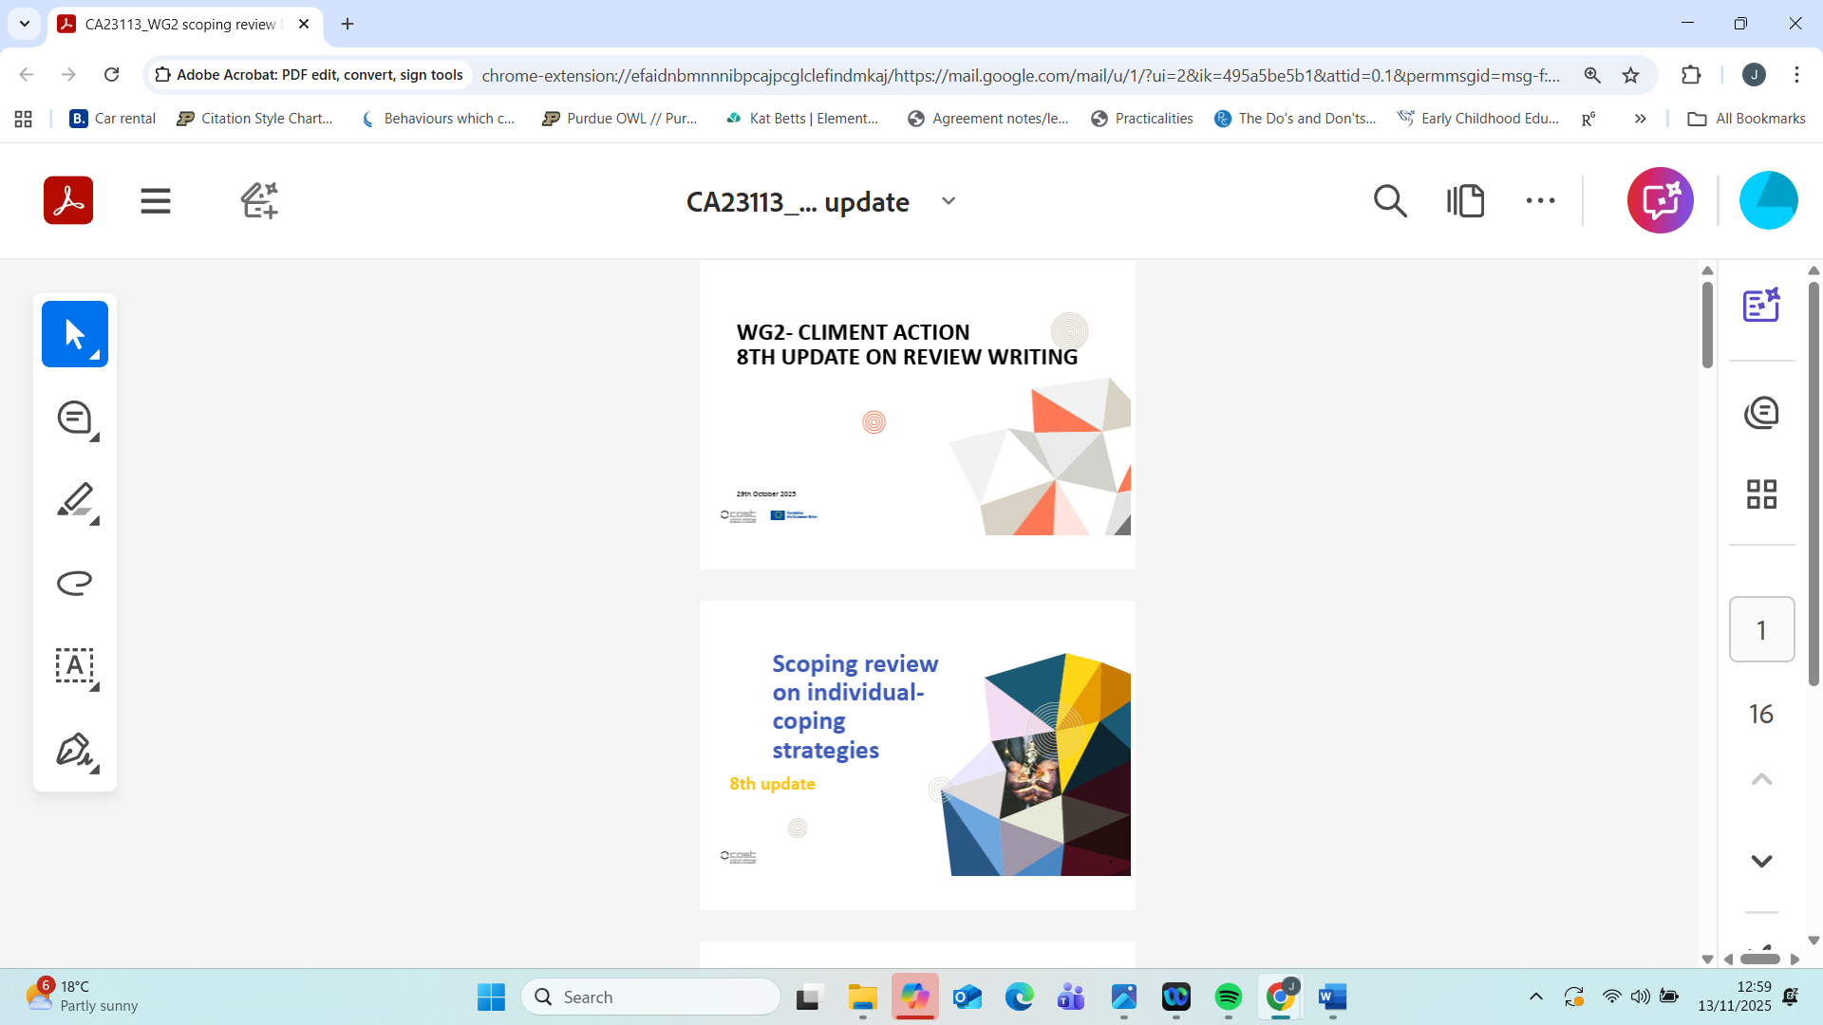
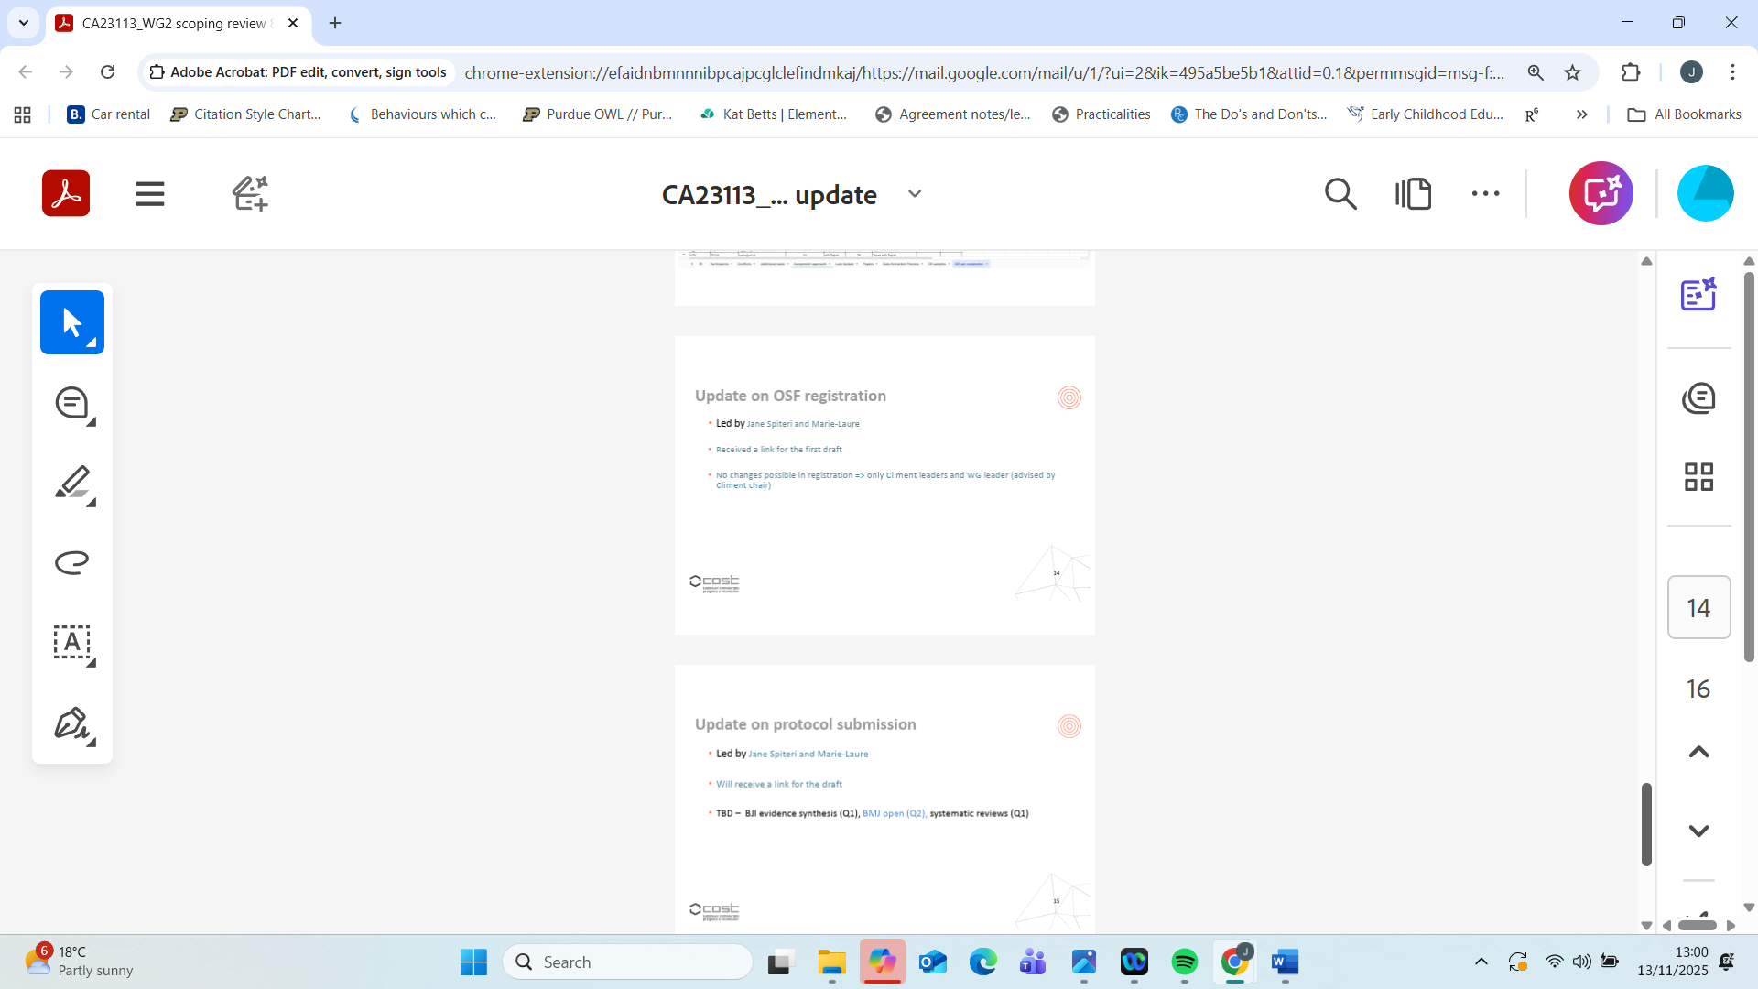

Overall, the VM period was marked by intensive collaboration, iterative feedback loops, and a shared commitment to transparency and inclusivity. There were no deviations from the original plan; timelines were met as anticipated, and both intended outputs, OSF registration and a ready-to-submit protocol, were achieved.
Description of the VM main achievements and planned follow-up activities
Description and assessment of whether the VM achieved its planned goals and expected outcomes, including specific contribution to Action objective and deliverables, or publications resulting from the VM. Agreed plans for future follow-up collaborations shall also be described in this section. (500 words)
The Virtual Mobility successfully achieved all its planned goals and expected outcomes. The OSF registration was completed, approved by co-authors, and made publicly accessible, marking a significant milestone for WG2 and the CliMent Action in terms of transparency and methodological rigour. The scoping review protocol was finalised and is now ready for submission to the JBI Evidence Synthesis Q1 journal for peer review.
These outputs directly advance Deliverable D2.1 (Scoping review on coping strategies) by providing WG2 with a robust methodological anchor that will guide the ongoing evidence synthesis. The process also supported Action Objective 5 (identifying adaptive and maladaptive coping strategies), Objective 7 (enhancing knowledge transfer and methodological capacity through open science practices), and Objective 8 (shared knowledge and best practices). Moreover, the inclusive and collaborative nature of the work strengthened capacity building, involving early career researchers and ITC members in all stages of protocol development.
The VM also enhanced interdisciplinary collaboration, bringing together scholars from psychology, psychiatry, public health, and education to co-develop a shared framework for examining coping strategies in the context of climate change-related mental health impacts. The OSF record now serves as an open-access reference for the entire network, ensuring harmonisation across WG2 and beyond.
Planned follow-up activities include:
Submission of the protocol manuscript to JBI Evidence Synthesis (Q1 journal), and subsequent peer-review process.
Launch of the data extraction and analysis phases of the scoping review, guided by the registered protocol.
Organisation of an online methodological workshop within WG2 to disseminate lessons learned from the VM and support other members in protocol development and registration.
Preparation of a policy brief (Deliverable D2.3) drawing on emerging findings from the scoping review.
In summary, this Virtual Mobility has provided the methodological foundation for one of WG2’s core deliverables, advanced the Action’s open science agenda, and strengthened collaborative and inclusive research practices within the CliMent network.

Communication Activity (for website or social media):
We are delighted to announce that Dr Jane Spiteri has been awarded a Virtual Mobility (VM) Grant under the CliMent COST Action (CA23113) to develop an Open Science Framework (OSF) registration and a scoping review protocol on unpleasant eco-emotions. This initiative will advance understanding of the unpleasant emotional dimensions of climate change across generations, while enhancing methodological transparency and interdisciplinary collaboration across the CliMent network. The resulting outputs will serve as a foundation for future research and dialogue on how individuals and communities experience and respond to the unpleasant psychological impacts of climate change in Europe.

This report is submitted by the grantee to the Action MC for approval and for claiming payment of the awarded grant. The Grant Awarding Coordinator coordinates the evaluation of this report on behalf of the Action MC and instructs the GH for payment of the Grant.

