COMMUNICATION ACTIVITY FOR A LARGER AUDIENCE ON VMG-
Besa Shahini
Content:
- Part 1- My post in LinkedIn (open to Public) communicating the VMG to a public Audience (pp1)
- Part 2- A draft LinkedIn Post, that might be posted by CliMent LinkedIn profile communication my VMG (pp.2)
- Part 3- A blog spot – A detailed VMG communication plan (pp.3-4)

Part 1- My post in Linkedln (open to Public) communicating the VMG to a general public Audience
https://www.linkedin.com/posts/activity-7363649681769279488-_ofd?utm_source=share&utm_medium=member_desktop&rcm=ACoAABMBGN4Bhw8SFgR0HK0lcuDB8J-Pp9ijhWo

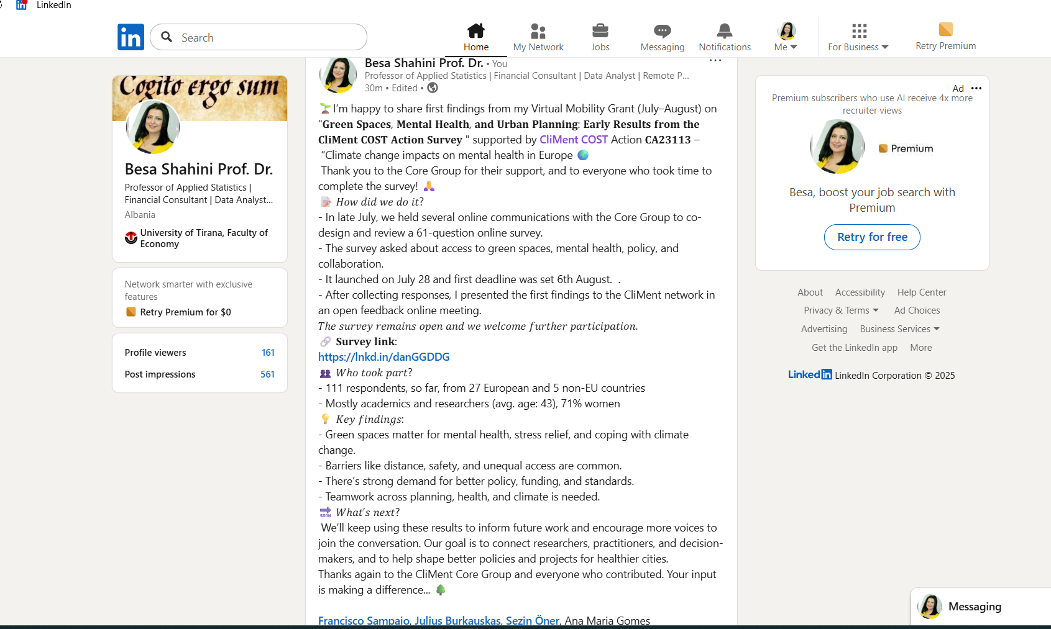

Part 2- A draft Linkedln Post, that might be post by CliMent Libekdln profile communicationg my VMG

🌿 Virtual Mobility Grant Results – Prof. Dr. Besa Shahini 🌿
We are pleased to highlight the outcomes of a Virtual Mobility Grant (VMG) carried out by Prof. Besa Shahini from University of Tirana, Albania under COST Action CA23113 (CliMent).
Between 22 July – 13 August 2025, Prof. Shahini led a collaborative study on Green spaces, Climate change, and Mental health resilience. The grant supported the design and circulation of a 61-question survey that collected so far, 111 responses from 27 European and 5 non-EU countries.
🔎 The study examined:
- How access to urban green and blue–green spaces affect community mental health and resilience.
- Barriers to accessibility and fair distribution.
- Policy needs for integrating mental health into urban planning and climate adaptation strategies.
📊 Preliminary findings show that:
- Green spaces are widely recognized as crucial for reducing stress, anxiety, and climate-related pressures.
- Access remains unequal, especially to blue–green spaces.
- Strong demand exists for cross-sector collaboration and for policies mandating urban green standards.
This VMG produced a shared dataset, an output report, and policy recommendations, providing a foundation for upcoming publications, workshops, and policy briefs across CliMent.
👏 We thank Dr. Shahini for her valuable work and contribution to advancing CliMent’s mission of addressing the mental health impacts of climate change through science, collaboration, and innovation.
#COSTactions #CliMent #ClimateChange #MentalHealth #UrbanPlanning #GreenSpaces

Part 3- A blog spot – A detailed VMG communication plan

Urban Green spaces, climate change, and mental health: what we’re learning
(COST Action CA23113 – CliMent VMG spotlight)

Green spaces aren’t a luxury. They are where people cool down, breathe easier, and steady their minds. That matters when heat, floods, and uncertainty add pressure to everyday life.
This story comes from a Virtual Mobility Grant (VMG) supported by CliMent – Cost Action and carried out by Prof. Besa Shahini (University of Tirana), a member of our Action, during July–August 2025.
The goal was simple: listen to CliMent CA members and not only, about urban green (and blue)–spaces and understand how these places support mental health and resilience—and where access still falls short.
What we asked
Prof. Shahini designed the first draft of a survey to learn three things: who can reach green/blue–green spaces, how they are used, and how they help people cope. The instrument has 61 questions across five areas: access and use, mental health and climate, policy, collaboration, and background demographics. The draft was consulted with core group members of CliMent and it took the final form and distributed on 28th July.
Till 6th August (first deadline for filling in the survey), Responses (111) already covered 27 European countries plus several non-EU states, giving a broad view of different settings and needs.
Importantly, the survey link remains open so more voices can be heard, and the evidence keeps improving.
Contribute here:
https://docs.google.com/forms/d/e/1FAIpQLSf4SMPXeWQCHaaZvklYXLEbzZM50N_LHBddBQOxcJ3-9aQ_jQ/viewform .
What we’re hearing
- People value green space strongly. They say these places lower stress, lift mood, and help during climate-related strain. Water matters too: blue–green areas (parks with rivers, lakes, coastlines) feel especially restorative.
- But access isn’t fair. Distance, safety, maintenance, and transport are common barriers. Access to blue–green spaces is even more limited, despite being highly valued for restoration.
- Respondents also sent a clear signal to decision-makers: we need urban planning, public health, and climate adaptation to work together. People support minimum green-space standards, therapeutic and inclusive design, and fair distribution across neighborhoods. And they want planners, mental-health professionals, climate scientists, and communities at the same table—by design, not by chance.
Why it matters
Climate change is also a mental-health story. Anxiety, worry, and fatigue rise with extreme heat, poor air, or floods. Green infrastructure helps people cope, cools streets, improves air, and offers places to recover and reconnect. Treating green space as both an environmental asset and a public-health necessity is practical and fair—not optional.
What this VMG delivered
This VMG did four things:
- Built a shared dataset for the CliMent network, ready for analysis across working groups.
- Produced a preliminary report with descriptive results and early recommendations to guide practice and policy.
- Laid the groundwork for further activities i.e. publications, a policy brief, and workshops, so findings reach researchers, practitioners, and policymakers in formats they can use.
- It also strengthened ties across countries and disciplines—one of the most valuable outcomes of short, focused mobility. The process—co-design, broad dissemination, collective review—means the evidence now reflects many contexts, not just one.
What happens next
The dataset into co-authored papers, a clear policy brief, and training and outreach materials (workshops, infographics). We will keep widening participation beyond the Action, bringing in city planners, health services, schools, NGOs, and community groups. And because the survey stays open, we can keep improving coverage, including places and people often missed in research.
What you can do
- City teams: set minimum green-space standards, budget for maintenance and safety, and plan cooling and shade were heat hits hardest.
- Health services: pilot nature-based referrals and link them to safe, accessible spaces and transport.
- Schools: make outdoor learning routine and ensure teachers have the training and resources to use local green/blue–green spaces.
- Communities: tell us what would help—paths, lighting, water, trees, places to sit. Your lived experience is essential.
Add your voice to the survey and share it in your networks (link above). Small contributions add up to a clearer picture—and better decisions.

